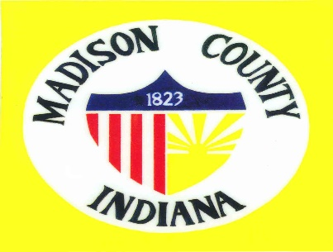Madison County Employees Discounts
AT & T (wireless): Need employee badge
H&R Block Discount (1410 Jackson, Anderson)
H & R Block Online
Airport Fast Park (link of madisoncounty.in.gov, under HR icon)
AVIS Car Rental (link of madisoncounty.in.gov, under HR icon)
Budget Car Rental (link of madisoncounty.in.gov, under HR icon)
Hertz Car Rental (link of madisoncounty.in.gov, under HR icon)
Hotels.com (link of madisoncounty.in.gov, under HR icon)
Rallys (Scatterfield Rd, Anderson)
Madison County YMCA: Need employee badge
LivRite Fitness Center: Need employee badge
Plant Fitness: Need employee badge
White River Fitness Center: Need employee badge
ZUMBA (Chesterfield Millcreek Center): Need employee badge
Community Sports & Wellness (Pendleton): Need employee badge
Benefit Hub (Need County Email)
Sam’s Club: Need employee badge
Revised 3-8-23

